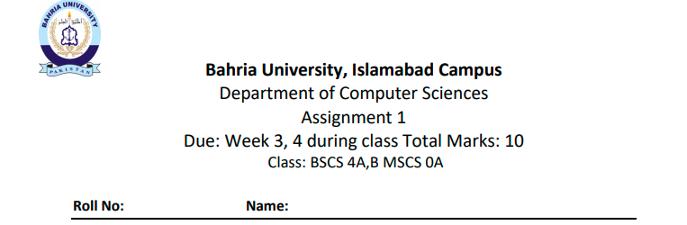

|  |  |
| --- | --- |
| 01-134192-030 | MALIK ZOHAIB MUSTAFA |
| 01-134192-056 | MUHAMMAD KHIZER WAHEED |
| 01-134192-106 | SHAHZAIB IQBAL |
| 01-134192-090 | ZAINAB TARIQ |
| 01-134192-075 | SAMAMA KHAN |



  
  
  



  
  
  